- Launch one Aws ec2 and install Jenkins.?

Step 1: Log in to AWS Console
Go to 👉 https://aws.amazon.com/console
Sign in to your AWS account.

Step 2: Open EC2 Dashboard
- In the top search bar, type EC2
- Click EC2 under Services

Step 3: Launch Instance
- Click Launch instance
- Give your instance a Name (optional but recommended)

Step 4: Choose an AMI (OS)
Select an Amazon Machine Image:
- Amazon Linux 2 (most common)
- Ubuntu
- Red Hat, etc.
👉 For beginners: Amazon Linux 2

Step 5: Choose Instance Type
Select instance size:
- t2.micro or t3.micro (Free Tier eligible)
Click Next / Continue

Step 6: Create or Select Key Pair
- Choose Create new key pair (or select existing)
- Key pair type: RSA
- Download the .pem file
⚠️ Keep it safe — you cannot download it again.

Step 7: Configure Network Settings
- VPC: Default
- Subnet: Any
- Auto-assign public IP: Enable

Step 8: Configure Security Group
Create a new security group and allow:
Type | Port | Source
SSH | 22 | Your IP
HTTP | 80 | Anywhere
HTTPS | 443 | Anywhere
Custom TCP | 8080 | Anywhere (if needed)

Step 9: Configure Storage
- Default is fine (8 GB gp2/gp3)
- Increase if needed

Step 10: Review and Launch
- Review all settings
- Click Launch instance

Step 11: Verify Instance Status
- Go to EC2 → Instances
- Wait until:
  - Instance state: Running
  - Status checks: 2/2 passed

Step 12: Connect to EC2
- Select the instance
- Click Connect
- Use:
  - EC2 Instance Connect (browser), or
  - SSH command provided by AWS
Example:
ssh -i your-key.pem ec2-user@<public-ip>

✅ EC2 instance is ready

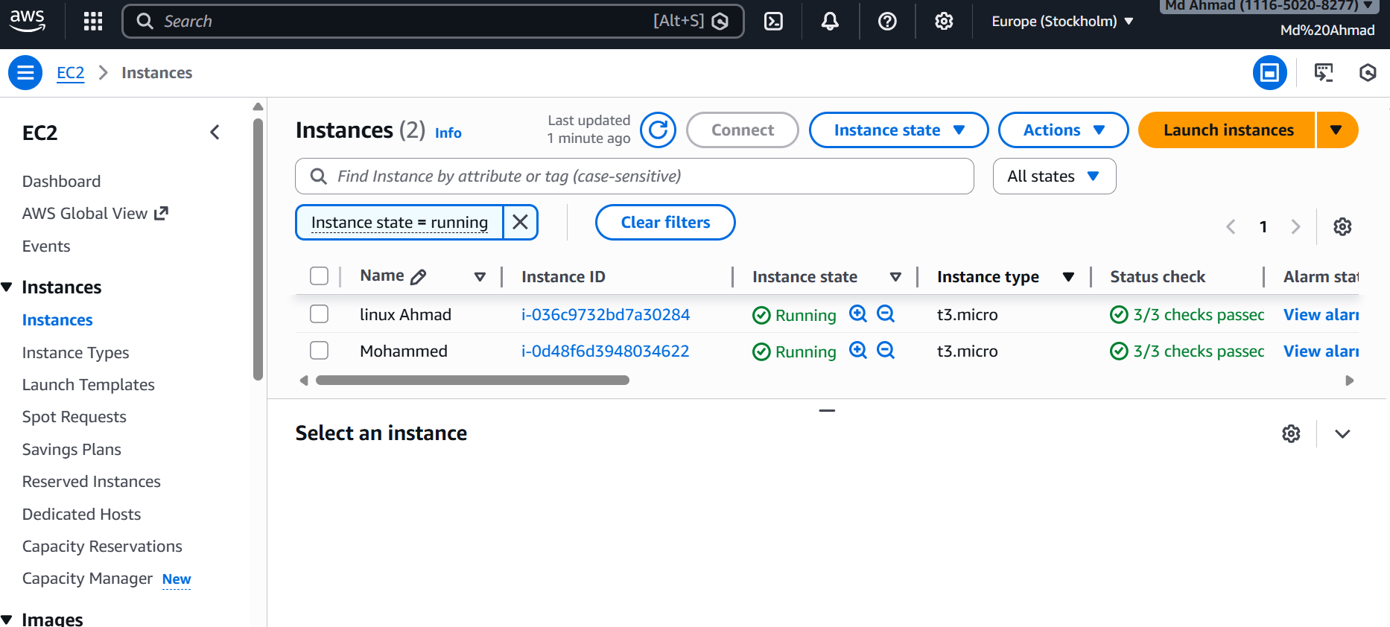
install jenkins?
I install Jenkins
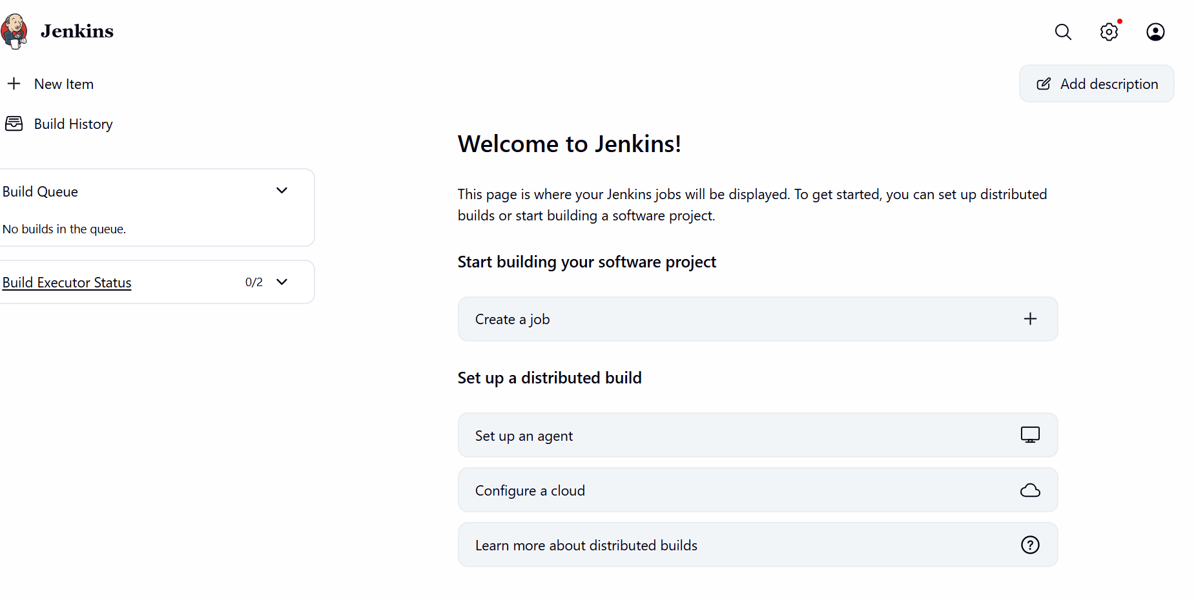
2 Setup Apache Tomcat on Ubuntu Virtual Machine?
Complete the setup of Apache Tomcat on Ubuntu
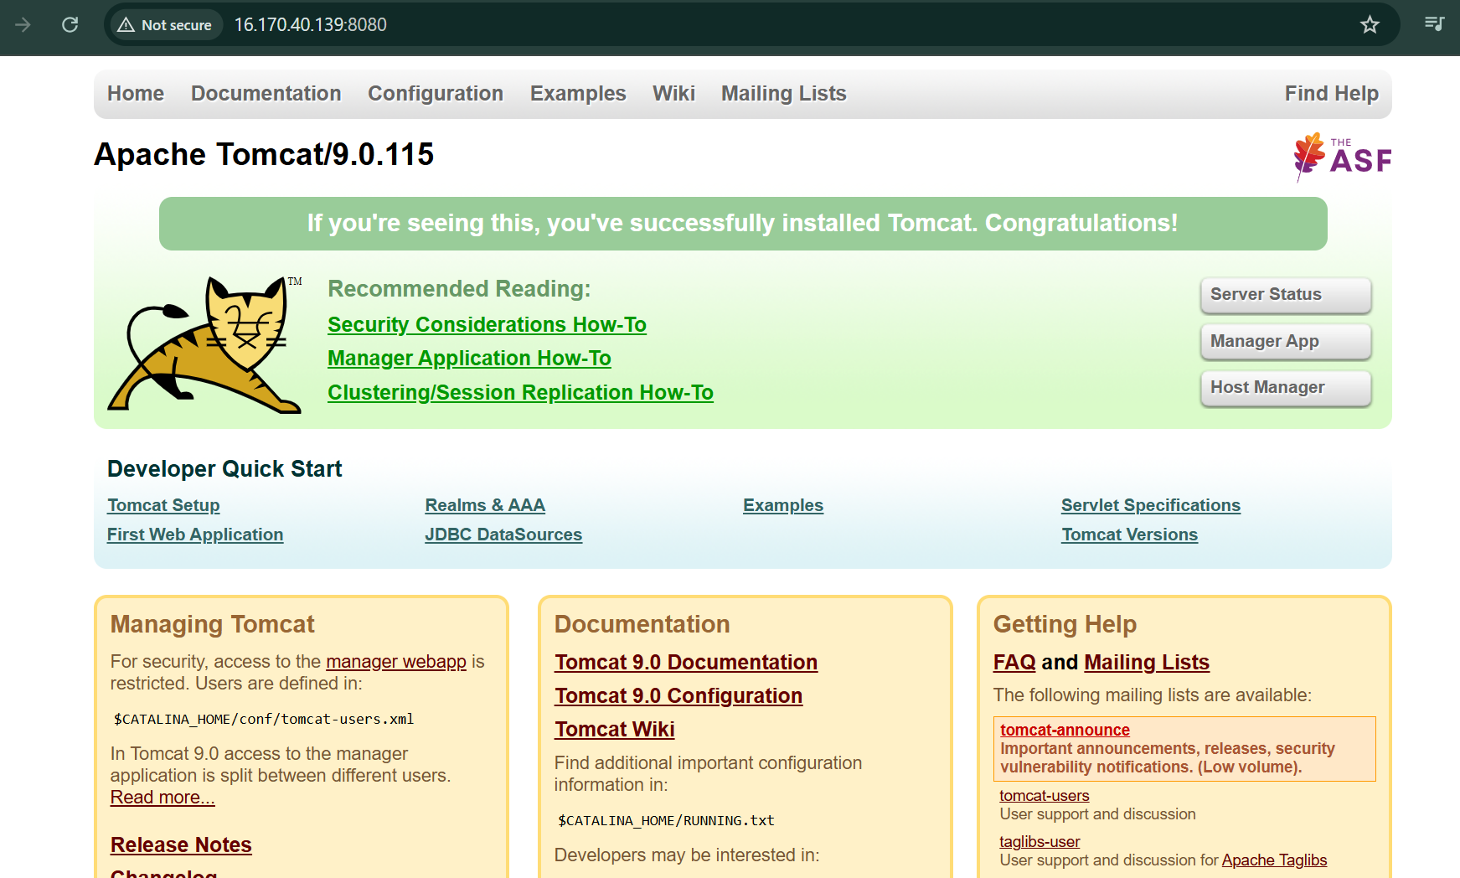

3 Setup Docker Desktop on your local windows.?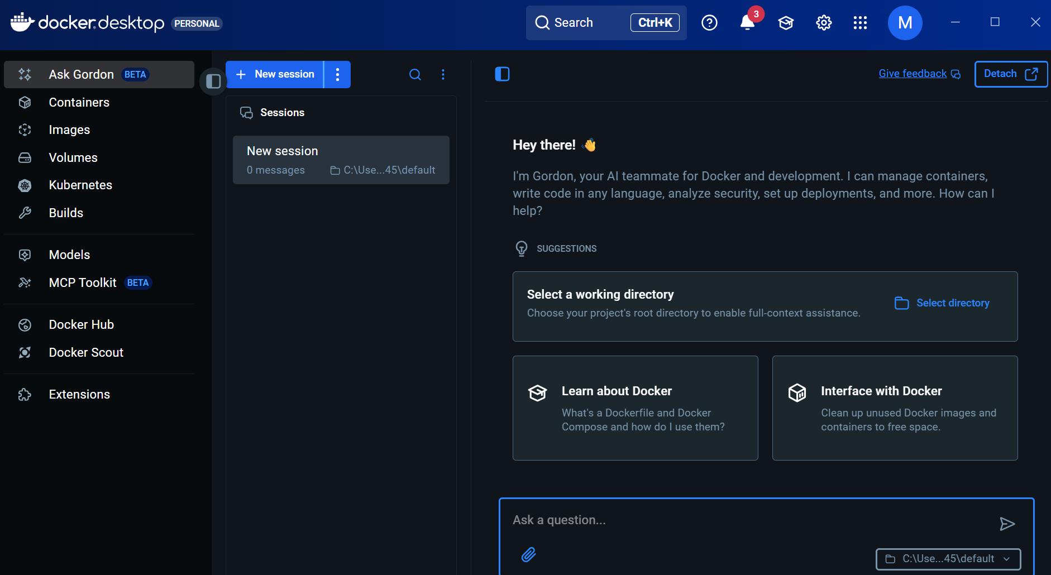
✅ Prerequisites (Important)
Before installing Docker Desktop, make sure:
- Windows version
  - Windows 10 64-bit (Pro, Enterprise, or Education)
OR
  - Windows 11 (any edition)
- Virtualization enabled
  - Enabled in BIOS/UEFI
  - CPU must support virtualization (Intel VT-x / AMD-V)
👉 If you’re on Windows Home, Docker still works using WSL 2 (recommended).

🔹 Step 1: Enable Virtualization in BIOS
- Restart your PC
- Enter BIOS (usually by pressing F2, F10, DEL, or ESC)
- Find Virtualization Technology
- Set it to Enabled
- Save and exit
📌 If virtualization is already enabled, you can skip this step.

🔹 Step 2: Enable WSL 2 (Required)
Open PowerShell as Administrator and run:
wsl --install
This will:
- Install WSL
- Install Virtual Machine Platform
- Install a default Linux distro (Ubuntu)
👉 Restart your system when prompted.
After restart, set WSL 2 as default:
wsl --set-default-version 2

🔹 Step 3: Download Docker Desktop
- Go to the official Docker site
👉 https://www.docker.com/products/docker-desktop/
- Click Download for Windows
- Download the installer (Docker Desktop Installer.exe)

🔹 Step 4: Install Docker Desktop
- Double-click the installer
- During installation:
  - ✅ Check Use WSL 2 instead of Hyper-V (recommended)
- Click OK
- Wait for installation to complete
- Restart your PC if asked

🔹 Step 5: Start Docker Desktop
- Open Docker Desktop from Start Menu
- Accept the Docker Subscription Service Agreement
- Docker will start and show “Docker Desktop is running” 🎉
🐋 You should see the Docker whale icon in the system tray.

🔹 Step 6: Verify Docker Installation
Open Command Prompt / PowerShell / Terminal and run:
docker --version
You should see output like:
Docker version 25.x.x, build xxxx
Test with a sample container:
docker run hello-world
✅ If you see a success message → Docker is working perfectly.

🔹 Step 7: (Optional) Enable Docker for WSL Linux
- Open Docker Desktop
- Go to Settings → Resources → WSL Integration
- Enable your Linux distro (e.g., Ubuntu)
- Click Apply & Restart

🎯 You’re Done!
You now have Docker Desktop running on Windows and can:
- Run containers
- Build images
- Use Docker Compose
- Work with Kubernetes (optional)

If you want, I can next help you with:
- 🚀 Running your first real app in Docker
- 🧱 Dockerfile basics
- 🐳 Docker Compose
- ⚠️ Fixing common Docker errors on Windows
Just tell me!

